Abuse Report System Install Instruction

1.System Requirement
1)Windows server/Linux server
2)1G Memory
3)1G Space
4)Tomcat (8.0 or above version)
5)MySQL(5.0 or above version)
6)JAVA EE (6 or above version)

2. Install Steps
1)Create the schema "51test" in MySQL
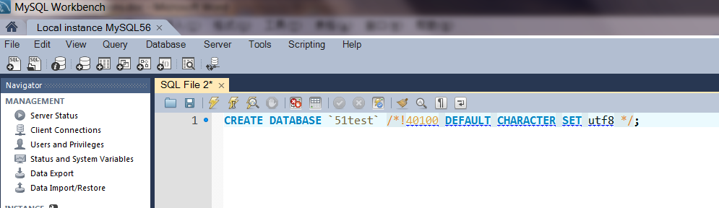
Run the command in MySQL Workbench:
CREATE DATABASE `51test` /*!40100 DEFAULT CHARACTER SET utf8 */;

2)Import the initial data(such as Authority, Admin account) to the MySQL
A. Click the MySQL Workbench import function
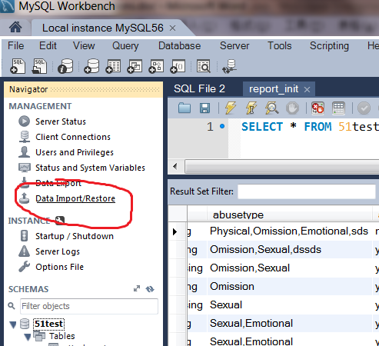

B. Choose the "MySQL_DATA" fold in "Install Instruction" folder, Click the start import to input initial data
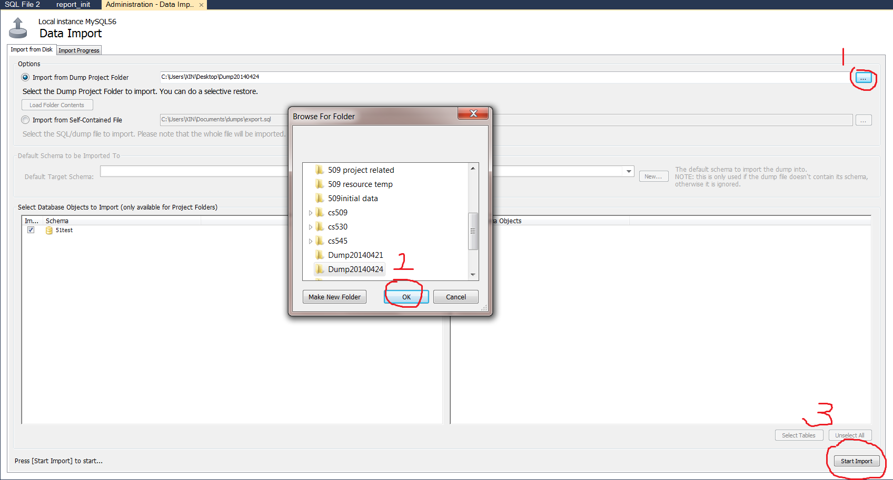

3)Modify the MySQL connection in "..\WebRoot\WEB-INF\config.properties"

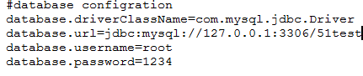

database.driverClassName:
Change it if use other database, only accept MySQL now.
database.url:
Change it to database server address.
database.username:
The account name to access the database.
database.password:
The account password.

4) Copy the "DOSS" folder to the tomcat path "..\webapps"
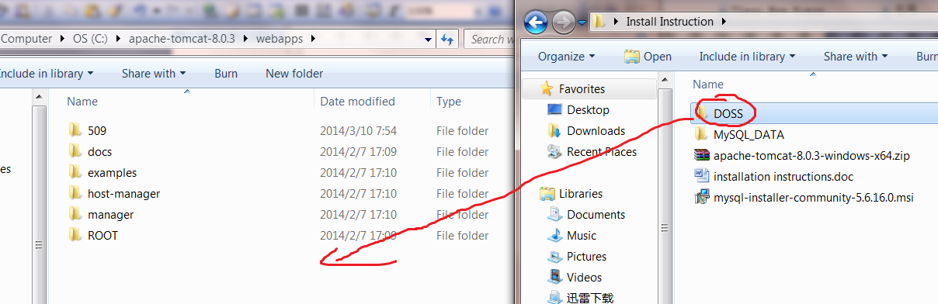

5) Run the tomcat
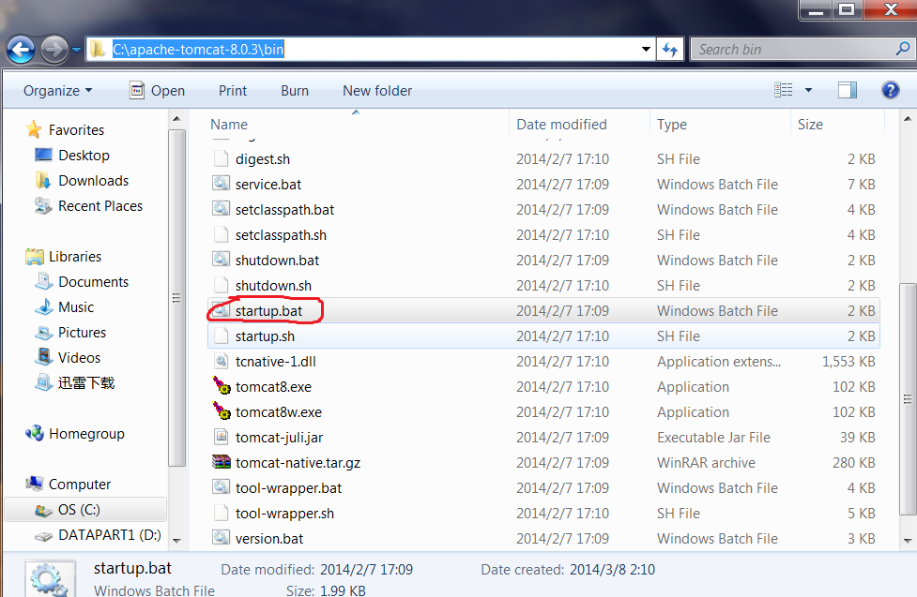
../apache-tomcat/bin/startup.bat

6)Input the URL such as "127.0.0.1:8080/DOSS" to access the application
